USER GUIDE

How to Use:

The Program gives you the calender of any

year that is given as input(less than 1010).

The initial Screen looks like this:

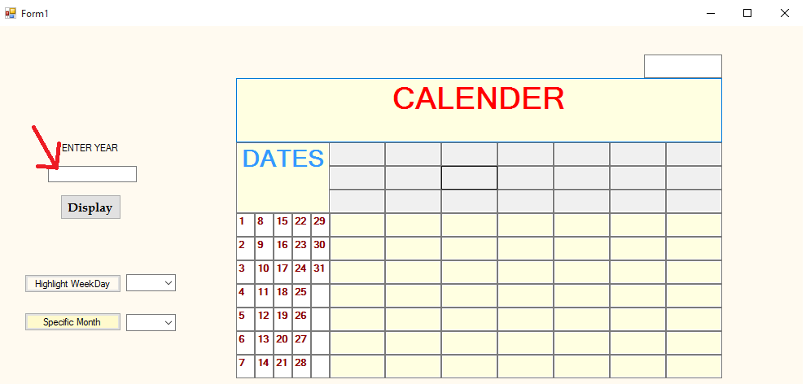

Choose the column containing the row you need and the row containing the date of that day. The Place where those intersect is the day of that date.

After Entering the input, click display:

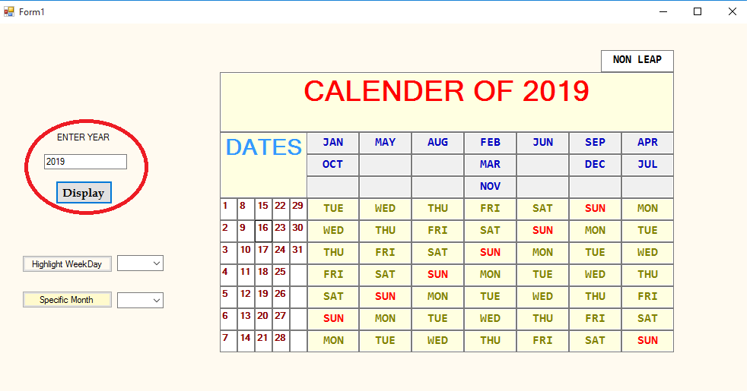

To Highlight a particular day of the week enter the input next to the “Highlight WeekDay ” Button:

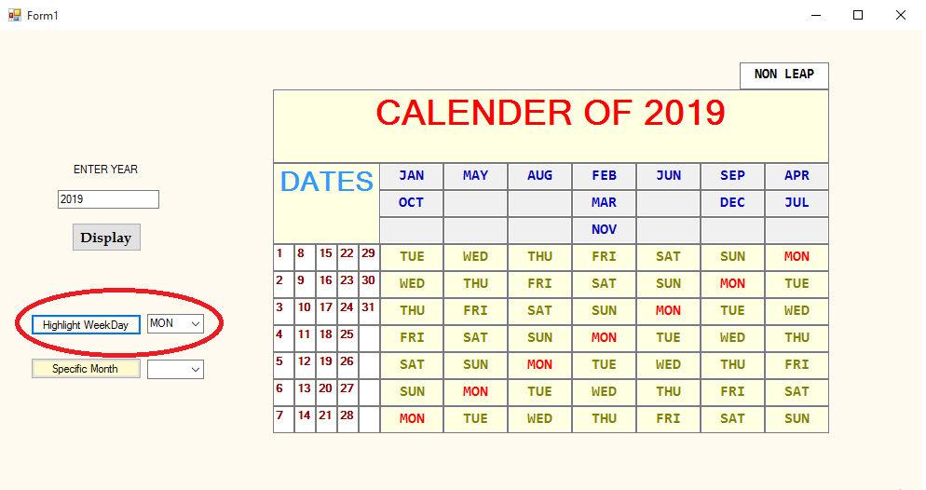

To Get a Specific month calender enter the month and press the “Specific Month” button:

